**S.MOHAN RAJ** 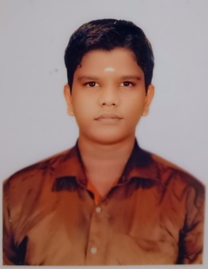

📞 : 8939532328

📧 : smohanrajbca2022@gmail.com

📍 : 12/14, Singara Garden 4th Street, Oldwashermenpet, Chennai-21

**OBJECTIVES:**

To achieve a challenging position in the field with my skills and ability and to attain professional growth that would given an opportunity to bring out the best in me and to the company.

**SKILLS:**

* Positive approach and adaptability to change.
* Optimistic , Energetic , Dedicated to Job.

**EDUCATION:**

**K.C.S. Kasi Nadar College of Arts & Science**

BCA(2023)

**Dr.MGR Educational And Research Instituate**

MCA (1st Year)

**COMPUTER LITERACY:**

* Languages: Java , SQL , C++
* Packages: Tally , MS Office (Word , Excel , PowerPoint)
* Web Technology: HTML
* Operting System: Windows

**ADDITIONAL QUALIFICATION:**

* Certificate with photoshop

**CO-CURRICULAR ACTIVITY:**

* Attended “Barclays Life Skills” Training by GTT Foundation

**PERSONAL PROFILE:**

Name : S.MOHAN RAJ

Father name : M.SELVARAJ

Date of Birth : 07:06:2003

Gender : Male

Marital status : Unmarried

Nationality : Indian

Languages known : Excellent command over English and Tamil.

**Declaration:**

I hereby declare that the above information is true to my knowledge.

Place : Chennai Signature

Date : S.Mohan raj